**FUNCTIONAL REQUIREMENTS**

**Basic function of HWM:**

In handwriting recognition (HWR) the device interprets the user handwritten character or words into a format that the computer understands such as Unicode text. The input device typically a touch sensitive screen.

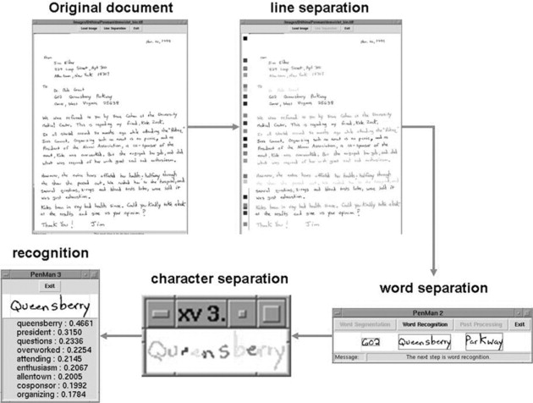

**Steps involves in HWR:**

It consisting an pre-processing, segmentation, feature extraction and classification. The offline system can optically scan document or image as an input.

**Functional requirements:**

The system should support the three stages of the writing

process, these are planning, translation (writing), and review. Within these stages it should provide ideas for planning, allow for fast and accurate transcription, and allow for the easy movement, alteration and deletion of characters, words and phrases.

It should include some spelling support and should incorporate file-handling facilities

The recognition component should be able to work even

when children write slowly, it should be able to deal with

‘wobbly’ writing,

**Data requirements:**

The system needs to be able to cope with multiple users, each user may have multiple documents and each document may have many files associated with it. These may be text files as well as ink files, and the text and ink files will be related. Each text or ink file may have updated versions following an editing process.

**Environmental requirements:**

For use in the classroom – the system needs to be robust, easy to learn and have on line help. It should not need an adult to make it work. It should be designed to work on a standard PC with a tablet and pen. The interface may be used in a noisy environment, or in a quiet environment – this implies that any sound output needs to be non-essential and easily turned off. Children are likely to be working

**User requirements:**

Users will be novices at the start but will quickly acquire competence. The primary users will be children of normal educational ability and without any motor dysfunction in their upper limbs. They will have reasonable vision and it is expected that the children will be able to read, but not with confidence. For this reason the words and language need to be kept simple and spoken output should be an option on the help screens. Children cannot be expected to be able to spell well, nor to be able to write cursively (although both will result in a better experience at the interface!). They can be expected to be able to hold and manipulate a pen, and to be able to construct even sized,

legible alphabetic characters in upper and lower case. Secondary users are adult helpers. These can be expected to be literate, and to be able to use a mouse driven GUI interface. They cannot be expected to be familiar with the handwriting recognition processes nor with the file handling of the application.

**Usability requirements:**

Children should be able to use the interface within their first ten minutes of usage. They should be able to use the controls without having to keep asking for help, and they should be able to access help from the system easily. The help should be presented to them in a suitable format for their age. Children should find the interface as easy to use and as quick to use as paper and pen.

**MERGING THE REQUIREMENTS:**

When the requirements were put together there was very little conflict as the things that the children wanted were mainly to do with the look of the product and add-ons. Once the requirements were put together, the system was designed.

**THE RESULTING DESIGNS:**

The design of the top-level navigation was based on the requirements from the classroom observations. requirements from the classroom observations. For this, knowledge of the process of writing, and knowledge of the architecture of the handwriting recognition software was needed.



**Tools used:**

This study is to identify AHDR on documented images with the use of machine learning methods[19]. At first, we need to construct a suitable model or method for training and testing[54]. The program able to extract characters one by one to get target output for training & testing model. The implementation and the experimentation of the algorithm had been carried out by using Python and supported with the usage of Graphical User Interface (GUI). We have used the Python 3.5 version, TensorFlow backend, OpenCV, sklearn, Kera’s it consists of the statistics and machine learning Toolbox which is used for training and testing the data using for different classifiers.

**Dataset used:**

The dataset is required for the training and testing[62]. The images of data are represented in datasets and it contain colored images. The dataset contains a total of 9096 images. From the available data, we have used 70% of the images for training the classifier and rest of the 30% used for testing.



**Conclusion:**

The primary focus of this research is to build an Automatic Handwritten Digit Recognition on document images, the important problem is segmenting adjacent digits inherit to the disjoint digits, overlapping digits, connected digits, variability of the digits, unknown length of the string, over-segmentation and under-segmentation. the development of the above system is not a problem. Water a reservoir is used to for segmenting two connected handwritten digits by using SVM, ANN and CNN method to find the best possible approach for isolating two adjacent digits.

.